More about Wes & Mo Blackmon
Some quick facts about Wes & Mo’s adventures in following Jesus:
- Both were born and raised in Flin Flon, Manitoba and both became followers of Jesus Christ in their 20’s. Mo joined St. Andrew’s Presbyterian Church in Duncan soon after becoming a Christian in 1986. She is an elder of that congregation since her (long-distance) ordination in 2002.
- Both understood their call to missions through life-changing experiences at Bible college - Wes at Providence College in Manitoba; Mo at Prairie Bible College in Alberta.
- Wes’ 1st mission experience was two weeks in Poland in 1998, through his local church in Brandon, MB. He has viewed himself and the world in a different way ever since. Mo’s 1st and only mission experience is in Latvia, from 1993 until now. It became her home and its people took root in her heart.
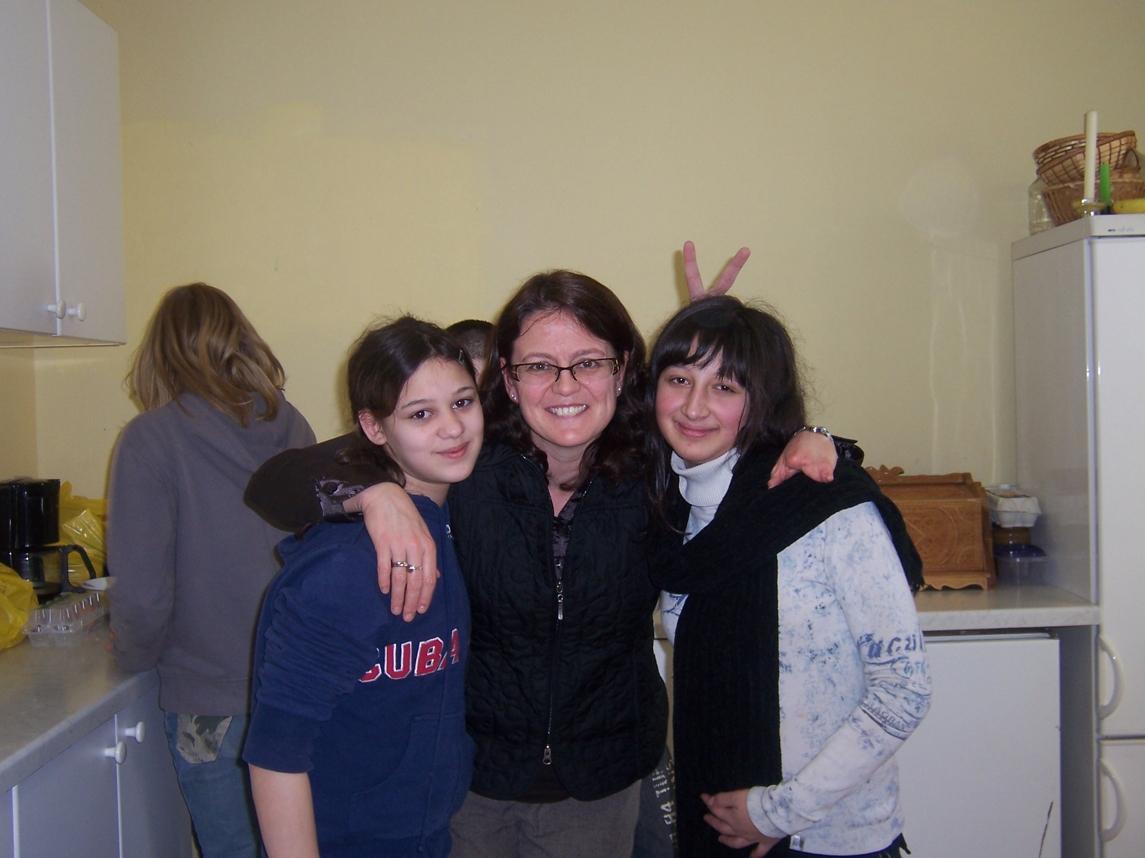
- Wes & Mo are long-term missionaries to Latvia with Greater Europe Mission. They are actively involved as mentors and resource people to Latvian pastors and church leaders, particularly in the areas of evangelism, deeper discipleship, and men’s outreach/accountability.
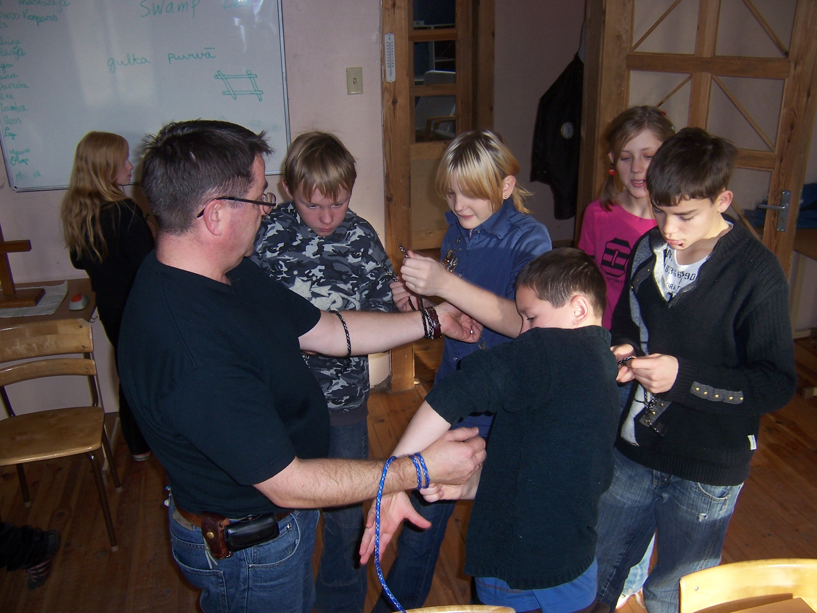

From left to right:
Mo with the girls during a cooking class, and Wes teaching Survival Skills at Youth Outreach.
Wes and Mo aren’t in this alone! This mission work is a cooperative effort involving not only the missionaries who literally ‘go’, but also people willing to partner with them through ongoing prayer and financial investment. St. Andrew’s & St. Stephen’s Presbyterian Church has been a vital partner in this work since 1996.
Wes & Mo Blackmon at wesandmo@latnet.lv
G.E.M. website: www.gemission.org

